Northern Nova Scotia 1000
By Luis Bernhardt
The last time I was in Nova Scotia was back in 1982 or thereabouts. Henry Hulbert and I (both of us with really low BC Randonneurs member numbers) were official Canadian Cycling Association commissaires at the time, and we accompanied ultramarathon cyclist and Canadian PBP pioneer Wayne Phillips on his cross-Canada cycling record ride. We ended up in Halifax after 15 days along the Trans-Canada Highway, over the majestic Canadian Rockies, along the two-lane stretch through Manitoba with no shoulder and lots of heavy truck traffic (THIS is Canada’s national highway?), along The King’s Highway #17 along Lake Superior in Ontario, riding through every province except PEI and Newfoundland.
So when I saw that Mark Beaver (can there be a more Canadian name?) had advertised his Northern Nova Scotia 1000, I was fascinated with the idea of exploring quite a large portion of his province on a bicycle. The route would even cross into New Brunswick, after following much of one arm of the Bay of Fundy reaching out to Truro, and then would trace the Northumberland and Eastern Shores. We’d miss the tourist areas like Peggy’s Cove, Lunenburg, and the Annapolis Valley, but those would be for another time. Instead, we’d get the Noel Shore, the “Mini Cabot Trail” from Cape George to Antigonish, and Sheet Harbour. I also arranged to stay for the remainder of the week in order to ride on PEI and in Cape Breton, although I had no plans to do the real Cabot Trail. Another time.
Flights between Vancouver and Halifax are more expensive than Vancouver to Europe, but I cashed in some mileage points and made the flight on Westjet. Stanfield International Airport (YHZ) is not in Halifax; in fact, it’s about a half-hour’s drive south to get to Halifax, even shorter to get to Dartmouth, where I had booked the hotel situated across the street from the ride start, a small gravel parking lot at Graham’s Grove, a small green space along Lake Banook.
Arriving the day before the start, I put the coupled bike together and rode to Halifax. Dartmouth and Halifax are separated by Halifax Harbour, the wide and busy inlet into Bedford Basin, and the closest bridge was closed to bicycles due to construction. Although a shuttle was available, I took the nearby Dartmouth ferry instead. It was $2.50 each way, $1.75 for seniors, and free for seniors on Tuesdays, which would work out great for the day after the ride when I needed to ride to Halifax to rent a car for the remainder of the trip. Car rentals are much cheaper out of the Halifax VIA Rail station than from YHZ, and the shuttle between the Halifax train station and YHZ is cheaper than a taxi between YHZ and Dartmouth, even for two people!
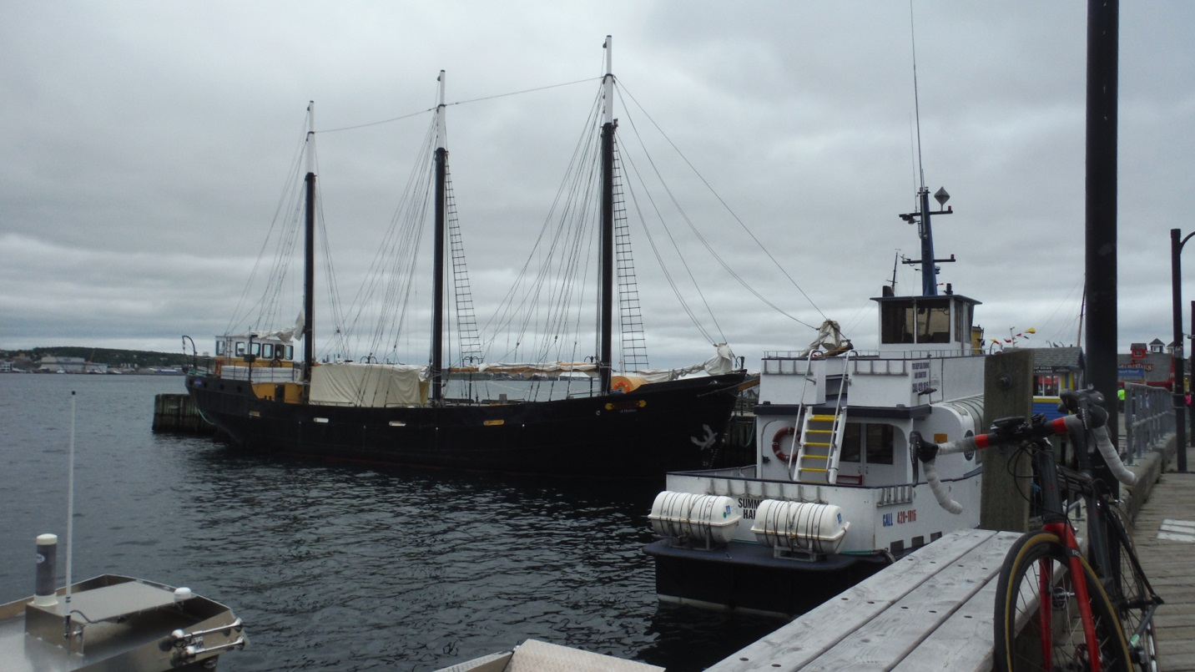
It was a quick and scenic ferry ride, reminiscent of New York’s Staten Island Ferry, but without the Statue of Liberty. Although I only needed to verify how to get to the train station/car rental agency (quite simple, actually), I noticed that Halifax had bike lanes downtown, and that despite its hills, cycling is still a great way to explore Halifax.
That evening, Mark Beaver stopped by the hotel to pick up drop bags and hand out maps to the out-of-province riders staying at the hotel. Ten of us would start the ride; there was a rider from Alberta and one from New Hampshire in addition to me at the hotel. Each individual drop bag would be shuttled between overnight controls – motels in Dieppe, NB the first night and Antigonish the second, then returned to the hotel for the finish, so we didn’t need to figure out what we’d likely need each day, we just brought everything in one bag. This was useful, as the weather forecast was not looking good for the first two days.
As usual, I had on two jerseys, more for the three additional pockets than the added warmth, but the additional insulation would be useful given the cool conditions at the start. I also had the reflective vest – the club version with its two additional pockets rather than the PBP version with no pockets. I had arm and leg warmers for the chilly 5 am start, plus a rain jacket rolled in one of my jersey pockets. I don’t like having bags of any sort on my bike, with the exception of the small seat bag that holds spare tubes and the most essential tools. I had finally got my lipstick charger to work with my Garmin 810, so I could have the Garmin running over an 18- to 20-hour day with no problem. The charger was taped to a Light & Motion 500-lumen backup light mounted upside-down below the handlebar (you can do this with L&M lights as the beam pattern is the same either way), and the primary light – a Serfas TL-500 – was mounted above the bars. The only problem on the ride occurred when water got into the inverted L&M light and it would function erratically. I have since been taping over the light’s recharge port.
Day 1 – Dartmouth to Dieppe, New Brunswick
The ten of us set off about 15 minutes past 5 am on Saturday morning. We took a very quiet and scenic route northwest out of Dartmouth, riding along Lake Micmac, then up and down gentle grades in quiet countryside. The first day was the most complicated routewise, but with the group it was not an issue. Riding with a group of strangers, the issues were to determine who the smoothest wheels were to ride behind, watching for gaps that would divide the group, and focusing on conserving the most energy. The group stayed together until the first long climb, then I suddenly found myself alone with two other riders. We pushed on until I felt some softness in my rear tire, so I dropped off quietly, not wanting the other two to stop and lose time. The larger group quickly rode past while I was removing the rear wheel, and a final rider caught me as I was finishing up the tube replacement. The cause was a radial tire wire poking through the tire casing, probably sustained on my ride to Halifax the previous day, as the roads we had been on were pretty clean, though wet.
This was the second time I was using the Soma Supple Vitesse EX 28mm-wide tires. The first time was at the Cascade 1200 where I had punctured three times. The tires are definitely more comfortable than the 23- and 25mm Vredestein tires I had been using previously. The Soma tires were also too fresh. I like to age tires for about three years before using them, but I was anxious to see how much more comfortable 28mm tires were, so I was using them while the rubber was still too soft and prone to picking up sharp objects, especially on wet roads. After three years, the rubber is supposed to harden and be less puncture-prone, but I was still building up my three-year supply of 28mm tires.
I continued on the ride, solo up the climb of Mt. Uniacke, the highest point of the ride, just over 200 meters. Nova Scotia does not have mountains; it has lots and lots of small hills that add up. After 200 km, you start to feel the hills. At 300 km, they become significant.
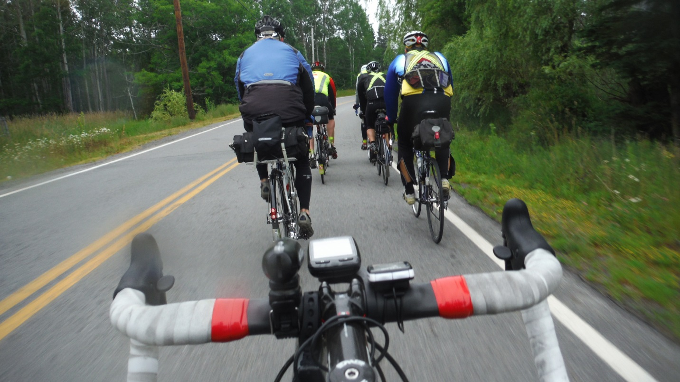
I caught up with the group, which had stopped at the first control in Burlington. Minimizing the stop, I left with two other riders, and we made good time along the Noel Shore section. This is a narrow, quiet road along the Bay of Fundy. Noel is one of the few villages along this road, and the route unfortunately did not take the short detour to Burncoat Head, reputed to be quite scenic. But we had 400 km to cover this first day. We stopped in Maitland at a store/restaurant as other riders caught up. After picking up some food, I continued, but I think everyone else must have stopped here for lunch, as I was on my own for the rest of the day.
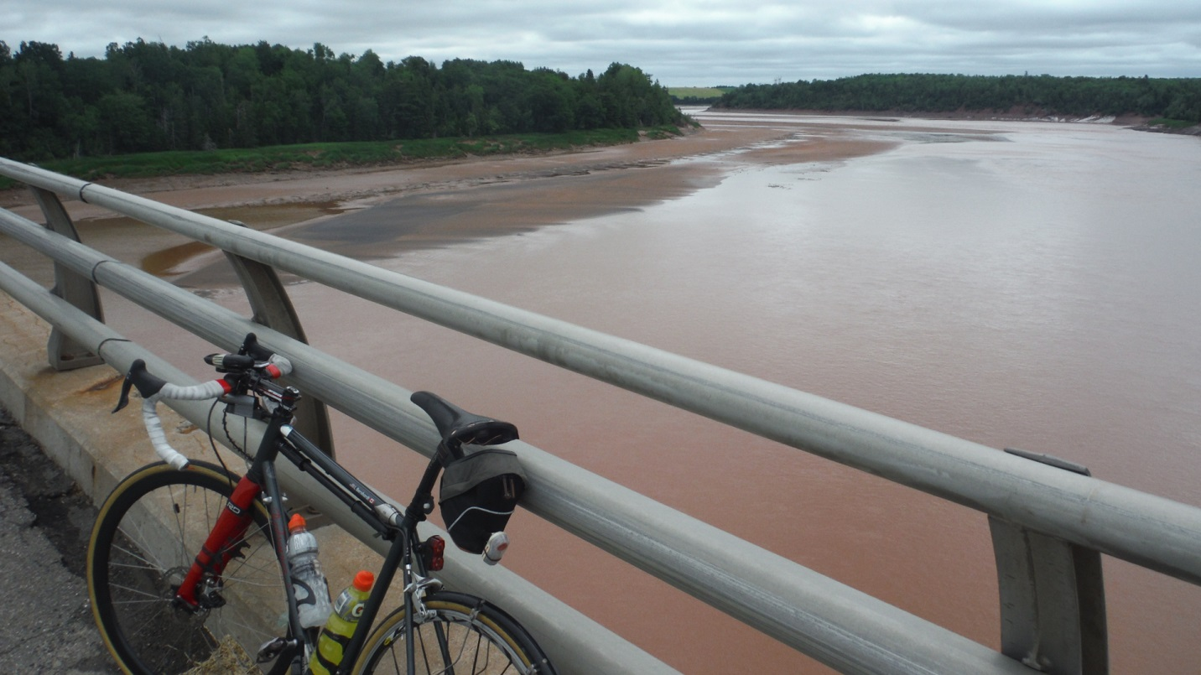
The theme for this first day was the Bay of Fundy, and as I approached Truro, I could see the red tidal mud left at low tide, especially over one long bridge spanning the shoreline. Past the southern edge of Truro, the route continued on quiet two-lane roads through the next control at Masstown, loosely following the shore to the right turn at Parrsboro. I was able to make good time on the gentle terrain, especially after getting out of the headwinds after Parrsboro, and heading north to Amherst.
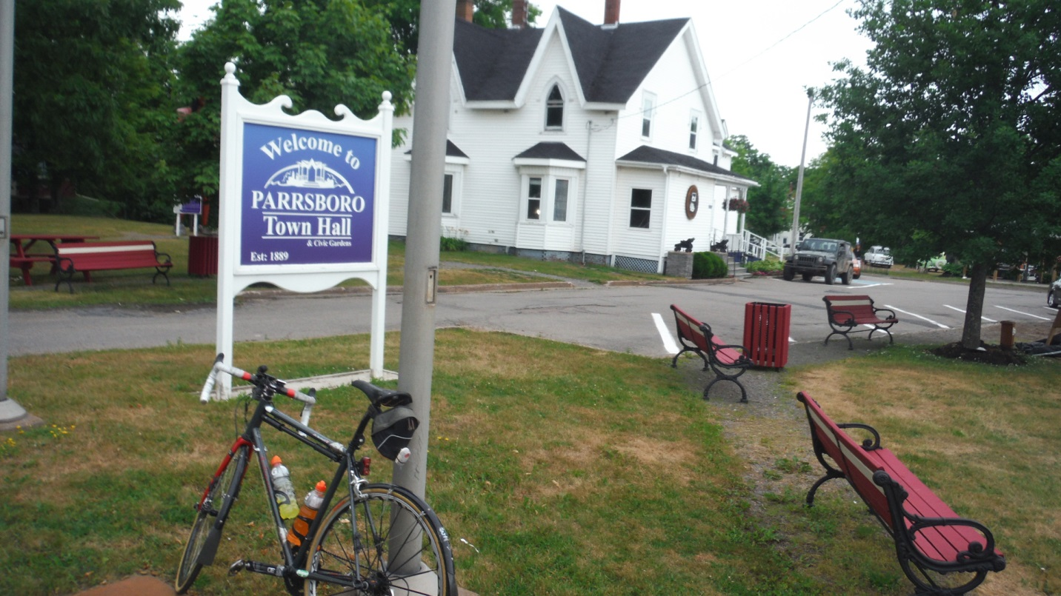
From Amherst, the route took us onto the Trans Canada Highway as we entered New Brunswick. The Trans Canada at this point is more of a freeway, with exit ramps and high-speed traffic, but a wide shoulder. We stayed on the highway for quite a while, passing the large Welcome to New Brunswick billboard, and finally exiting to Sackville, “home of Mount Allison University.” Evidently, Sackville is a popular name in the Maritimes, as very early in the ride, we passed through Lower Sackville, a suburb of Halifax. The route continued past Sackville on a medium-traffic road, then abruptly turned left onto a construction site that led to Memramcook, a picturesque village with an impressive church, Saint Thomas, set on a hill overlooking our route into town. Night was falling, but I had to admire this edifice reflecting the sunset as I dodged the construction and climbed the hill towards the building.
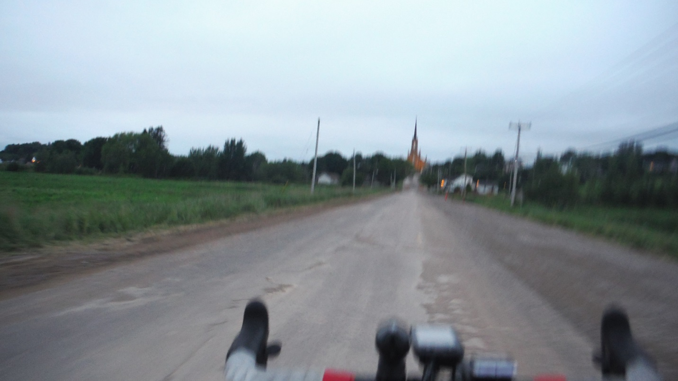
It was dark by the time I reached the outskirts of Moncton/Dieppe. I had wanted to stop to have a look at the relatively new outdoor velodrome they’d built in a park on the way into town, but just navigating to the overnight control was enough of an issue that I decided to leave this for another time. As it was, I missed one turn, but caught myself within 50 meters and figured out the correct route. Often, the Garmin will stop giving directions, so I’ll need to look at the traced route – not easy when it’s dark and the Garmin illumination turns off after about 30 seconds – and figure out where to turn. I reached the motel by around 10 pm where the volunteer crew had our bags and quite a bit of food. After a shower, other riders started arriving, including my roommate, David Ross, a Nova Scotia randonneur who would later arrive in BC to ride the Rocky Mountain 1200 with his friend Mark Beaver.
Day 2 – Dieppe to Antigonish, Nova Scotia
Next morning, after a typical hotel breakfast, we started en masse to the northern shore of New Brunswick. Though not a control, we stopped at Port Elgin to resupply. Port Elgin is still in New Brunswick, and had we gone northeast from here, we would have reached the Confederation Bridge to Prince Edward Island. Instead, we went south and crossed back into Nova Scotia at Tidnish. From here we followed the Northumberland Strait along the Amherst Shore. It had been largely overcast all morning, so there was no chance of seeing PEI far off in the horizon.
There were only two controls this day, the first in Wallace. The support crew carrying our overnight bags met us here to sign cards and to inform us that the restaurant noted on the control card was running slow, and recommended another restaurant down the road. I stopped at the convenience store immediately across the street, picked up some snacks, and quickly rode off. I didn’t see where the others had stopped, so I continued on my own.
I’ve always thought “Antigonish” is one of the best names to give a town in Canada, but “Pictou” also comes close; it sounds like it belongs in Nova Scotia. But then there’s “Pugwash,” located shortly before Wallace. I visualized a bunch of stubby dogs on a conveyor belt going through a scaled-down car-wash. What’s also notable about riding in the Maritimes is the number of universities located here. Dalhousie in Halifax is probably the biggest, but it has an agricultural campus at Bible Hill, near Truro. Sackville, NB has Mount Allison. Antigonish has St. Francis Xavier, all highly reputable, and these are just the universities we rode past. Higher education, along with tourism, forestry, and what’s left of fishing, appear to be the biggest industries in the Atlantic provinces.
After turning north to the Northumberland Shore at New Glasgow, where I stopped at the Subway for lunch at the day’s second control, the hills became more pronounced and repetitive as the rain started to come down. We had been warned to take it easy on the descents near Cape George, but so far, none of the descents had been anywhere near technical. The road was heavily pot-holed in places, so I had to be careful to avoid these. But entering Cape George on the steep run-in, I actually had to brake for the turns, and not just because of the wet roads. The road suddenly went totally out of character, replacing gentle bends with some steep, sharp corners. I took this opportunity to stop and take some photos of the rugged coastline, often compared with the Cape Breton Highlands part of the Cabot Trail.
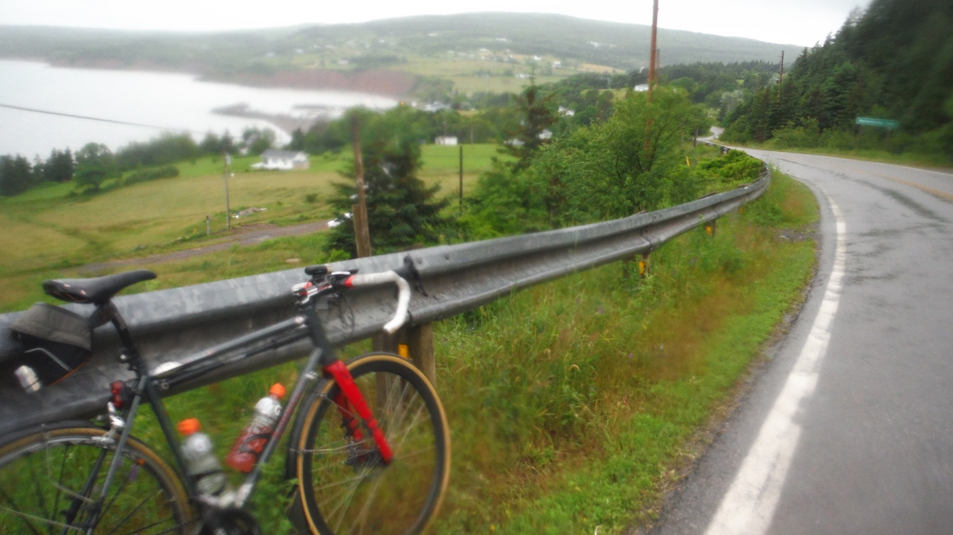
The last section of the day took us south to Antigonish, along more continuous up and down roads. It was still light when I reached Antigonish, but considering the condition of much of the road I’d been over, I was happy to have managed to avoid riding this section in the dark. I was pretty wet by the time I reached the overnight motel control, but I laid my wet clothes on chairs near the room heater and cranked up the heat before leaving for dinner. David Ross arrived a little while later, probably colder and wetter than I had been, but he thanked me for having the heat blasting when he got in!
Day 3 – Antigonish to Dartmouth
I left Antigonish by myself early on the last day because I didn’t want to double back along the route to the nearby Tim’s for breakfast. This final day was only about 200 km, and the weather was expected to improve significantly by noon. The roads were still wet at 5:30 am, but it was no longer raining, although it was still very cool. Navigation would not be a problem; it was Highway 7 all the way to the finish, with the best part of the ride along a quiet road south to the seashore, accompanied by a nice tailwind.
That wind and the constant hills would be the day’s biggest challenges. Although I started with a tailwind, once on the Eastern Shore, the route turns southwest. But because the road constantly skirts the inlets along the Atlantic, you face blasting headwinds and crosswinds anytime you round a corner and head north or east.
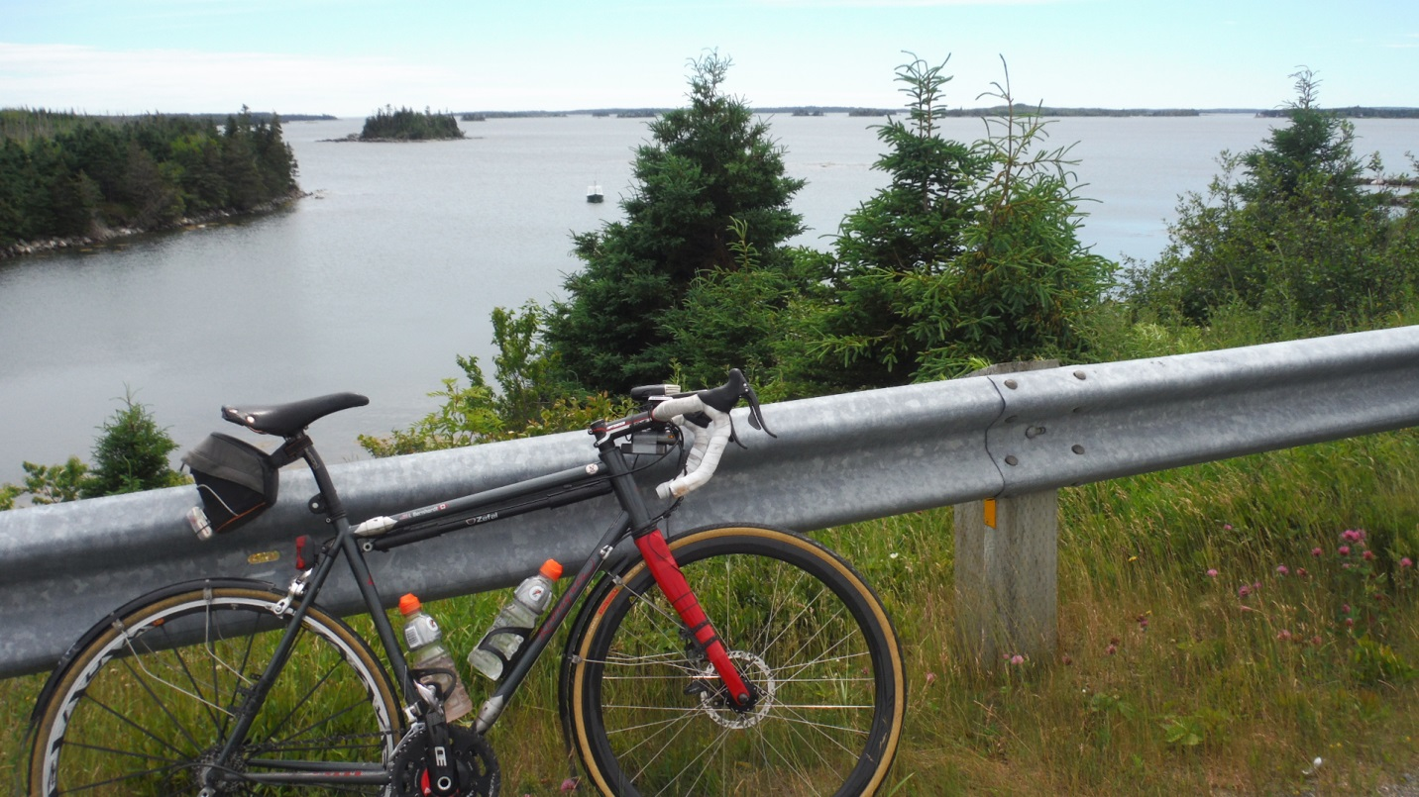
I stopped at the day’s only control, a seafood restaurant in Sheet Harbour, and had a bowl of chowder and a plate of onion rings. Lots of onion rings! All chowder in the Maritimes is the creamy New England style, rather than the tomato-based Manhattan kind, according to the elderly waitress who sounded like she’d be able to cook a mean pot of chowder herself.
The municipality used to be called Campbelltown in the early 1800’s, but it became known as Sheet Harbour due to a flat white rock that looked like a sheet, called Sheet Rock, of course, located at the mouth of the harbor.
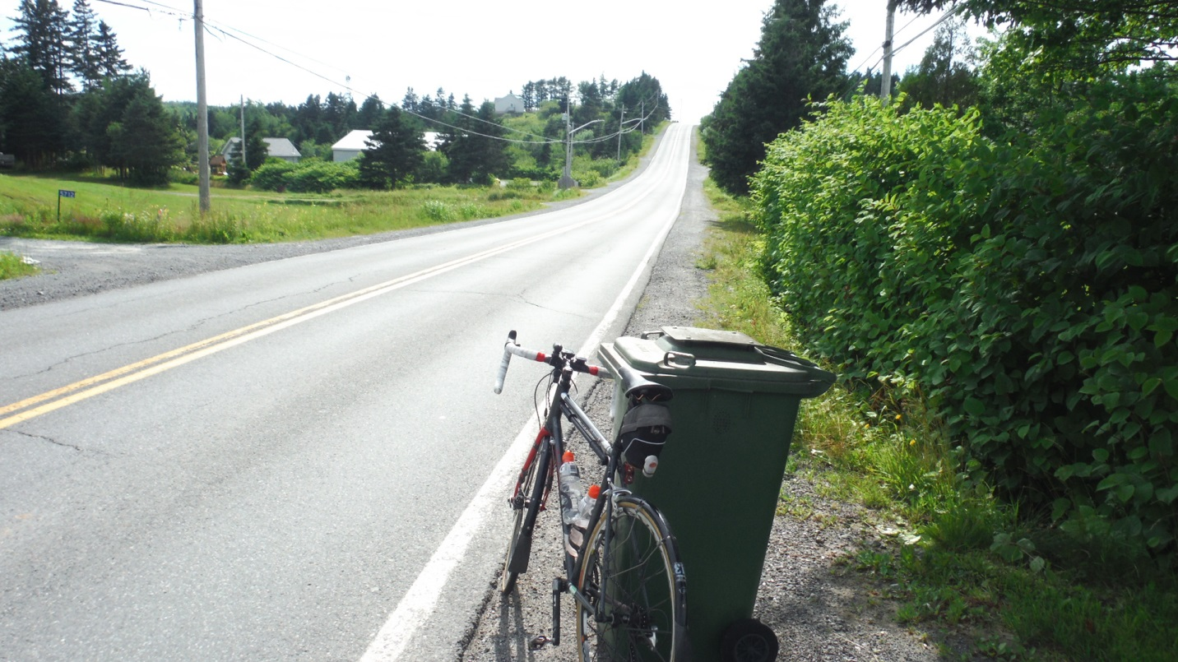
While I was eating, the clouds had disappeared and the temperature had warmed considerably. I was able to take off the arm warmers and set off for Dartmouth in shorts and short sleeves. Right into Dartmouth, there were the constant low hills, long enough that I had to shift to the small 34-tooth ring to get over them comfortably (I was running 13-25 in back). Traffic volume picked up the closer I got to Dartmouth, but the wider streets came with decent shoulders. I passed a lake on the right, and the road descended from there into town. At the bottom of the descent, after negotiating the offramps, I passed by the small park where we’d started two days prior, and swung into the hotel to get the card signed by the receptionist. It was late afternoon, so the small pub inside the hotel was open for dinner. All in all, this was a very satisfying 1000 km ride over some very scenic terrain that put some of the best parts of the Maritimes on display.
Ride dates: July 9-11, 2016

