The Sorrento 300 Km Summer Brevet
E.W. (Wim) Kok
Every year the Southern Interior section of the BC Randonneurs organizes a number of make-up brevets, so to this year. While in Salmon Arm for a week of holiday with the grandchildren I took advantage of the opportunity to ride one of the make-ups: the 300 km. Early Saturday morning quite a few randonneurs gathered at the home of Bob and Susan Goodison just outside Sorrento. Groups started at different time and in different directions for their respective distances and routes, in the process had to turn their backs on one another.
At seven am four dapper souls went off for the 300km brevet First down to Sorrento to get on to the TransCanada toward Chase. The skies were clear and traffic very light, which made for great cycling. After a few kilometers we were hugging the shoreline of Shuswap Lake, its surface like glass. It was a beauty. At Squilax the lake choked and narrowed for a short section in the Thompson River. It then widened again as Little Shuswap Lake. Then the first climb up the (in)famous Chase Hill.
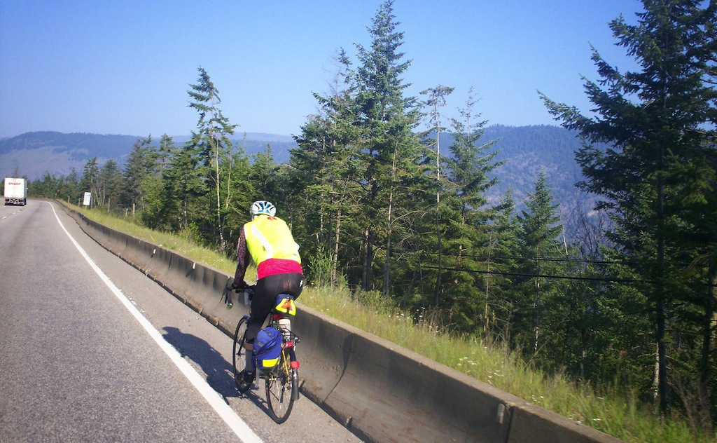
TransCanada Highway to Chase Credit: Bob Goodison
As I was nearing the top Bob Goodison caught up. The hill was not too difficult; the same could not be said for the turn-off into Chase. I thought it was a bit further downhill; luckily Bob alerted me in time to put on the brakes to come to a near screeching halt just in time for Shuswap Avenue. The ride through Chase was a pleasant surprise. At a creek crossing we stopped to answer the brevet card question at the first control (Chase Km 21). While Bob waited of Gary and Christine, I continued leisurely through Chase and enjoyed the smell of freshly cut hay.
After a short section on the TCH the route took the Chase-Falkland Road, which offered three challenges: first, ascending a steady and almost arduous hill to get onto the plateau; second, crossing couple of few cattle-guards, which can be hard on the rear-end, if one misses the smooth strips across them; and finally, a 6.4 km gravel section. Soon after reaching the plateau I heard a few dogs barking in the distance. They did not sound too energetic; sluggish was more appropriate. A bit later I saw a sign identifying the entrance to the “Retired Dog Farm”. That explained the nature of the lethargic bark. The 6.4 km gravel section was no problem as the surface was dry and tightly packed. As the temperature rose, it did not pose much of a problem, because the treed hill and side shaded the road quite nicely. At Pillar Lake (Km 57) there was another info control. A couple of lonely fishermen cast a few lines on the placid waters (with due credit to David Adams Richards: Lines on the Water: A Fly Fisherman’s Life on the Miramichi).
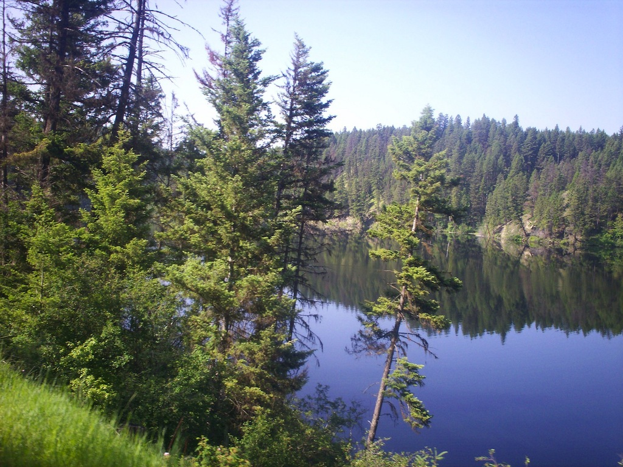
Pillar Lake Photo Credit: Bob Goodison
Answered the question on the card and continued, not realizing how much we had to climb (gradually) until the descent into Falkland confirmed it. While it was tempting to sit down for a coffee in Falkland, I decided against that and continued East on Hwy 97 to the Salmon Valley, meanwhile enjoying the views of the valley below. The 33 km Salmon Valley Road is a very attractive section to cycle. Pastoral in nature with many rural properties -- some actively and others not so actively farmed – and a few general stores and schools. The closer we got to Salmon Arm the larger and more prosperous the farms. As I pulled into the Salmon Arm (Km 122) control, Bob pulled out for his next leg. I spent some 20 minutes to eat, drink and recover. On my way out I saw Christine going toward the control. It was getting so warm that by the time I was back at Hwy 97, I needed to stop and take on more food and water. The next 17km to Falkland was a rather slow affair. My ride plan however was right on schedule, which meant that I could afford a break at the next control (Falkland 172 km). I was ready for it. Here I enjoyed a bowl of navy bean soup and garlic bread, as well as a brief snooze. Not bad. That’s was all I needed.
After about 30 minutes I was back on the bicycle to Westwold, where I had to look twice before I believed what I saw. Here was a gentleman in a field practicing what looked like a variant on the theme: “putting the cart before the horse.” In his case however he had put a llama before a golf cart and was riding it through the pasture. It left me wondering whether I had just seen the prototype of a post-modern 1930’s Bennett buggy. Funny!! I just laughed at the sight and continued past Monte Lake. A few short, but trying ascents, then Monte Lake and finally the Barnhartvale Road, the last few clicks of which require a few bike handling skills. Done right it is a great slalom. Just let the machine take you down and around the many sharp curves to the left and right. Exhilarating! Staying relaxed is the key. After arriving at the Kamloops Dallas PetroCan (Km 235), I took a 20 minute break, this time under a shade tree. Life was good. Only 65 km left to the finish. Most of this was on the TCH going east through the Thompson River Valley. While traffic was light, it became lighter yet as the evening progressed. Similarly, as it dropped the temperature became more bearable. Just before Chase, it was time to put on my lights. Then up and down the Chase hill -- this time in opposite direction. After the turnoff on the Dillworth Road there was only mile to go and by the way another lump. There it was: a red flashing (tail) light on the BC Randonneurs sign as a beacon in the darkness. I was quite happy with the time of 14: 51, considering that the temperature rose to 34C during the day. I very much enjoyed this 300 km route. Thanks to Bob and Susan for their hospitality and for organizing this brevet.

