A Rough Diamond: Summer Brevet in Britain
by E.W. (Wim) Kok
Introduction
Just before the RM 1200, Air Transat advertised Edmonton-London return flights for $ 749.50 or so. That sounded like steal of deal for summer travel to the Continent, so I stole and booked it. With an EasyJet connecting flight to Amsterdam, the fare was very reasonable. I had taken the bicycle along for an opportunity to first cycle a bit in the Netherlands and then ride a Brevet in Britain. I had consulted the AUK Calendar, narrowed my choices to a 300km ride near Tewkesbury and then contacted Mark Rigby, the event organizer, who by the way also organizes the Bryan Chapman Memorial brevets. He e-mailed the route sheet, so that I could get a bit of an impression of the route, the sheet layout and language. There were a couple of notable differences; mrb – mini roundabout - traffic circle without an islands in the centre, but just white dots on the road and RBT, a roundabout with and island. A bit more puzzling were the ‘PHs’ or public houses, two of which would serve as controls on this brevet. What to make of that? Then it dawned that these public houses are much better known as pubs. The route was described as “roughly diamond shaped with three controls and one info control, easy to navigate with stunning views and scenery. It follows many of the English and Welsh river valleys.” Vertical elevation gain 2,217m or close to 7,400 ft. Highest point 244m asl. The profile showed four ‘peaks’ and a lot of minor rolling terrain.
A Rough Diamond 300 Km Brevet Profile of the Rough Diamond
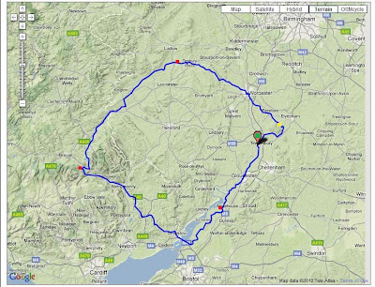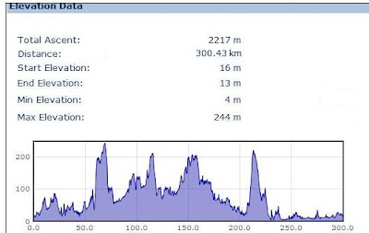
Source: http://challengemenace.blogspot.ca/2012/08/a-rough-diamond-300k-audax.html
Arriving back in London travelled by train to Tewkesbury and booked in at the local Travelodge, where I assembled the bicycle later that evening and picked up a few groceries. The forecast called for warm and sunny weather with temperature up to 23 ⁰C. The air was quite humid, no surprise considering the proximity to the Atlantic.
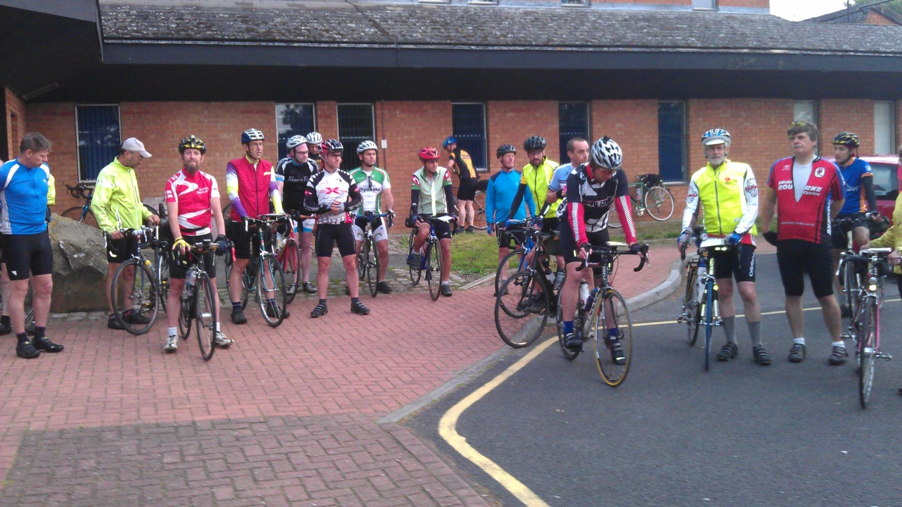
Start at Tewkesbury Borough Council Offices 5:00 am. Credit: Lou and Mark Rigby
The start control opened at five in the morning. After the necessary paperwork and a few pictures, the ride got underway at 6:00 am sharp. There were 22 participants including ‘this chap from Canada’ as someone described me in his blog. We cycled through the deserted streets of Tewkesbury into the countryside. There was quite a haze – thick enough that the rising sun had some trouble getting through. Rabbits were out in full force, which made me comment that we’ better avoid a collision with the unpredictable bunnies. One of the riders interpreted this as “Mr. Canada being quite alarmed to see a rabbit run across the road.” When asked what animals we had to contend with at home, I replied moose, elk and bears. Small or large, I guess each country has its own wildlife challenges. The first control came after some 20 km, an information control with a question about the mail drop box to ensure that we indeed covered the NE section of the circuit. Here the pack dissolved and the pieces continued at their own pace through small towns toward Worcester. So did I, only to be joined a bit later by another rider, who after my introduction as Wim from Canada -- and my explanation that this was an abbreviation for Willem or William -- returned the courtesy by introducing himself as Rhisiart Ap Gwilym, the Welsh version of Richard, son of William. We rode and conversed our way to, through and out of Worcester, where we had to do a few (re) turns to get back on track on very narrow pathways through residential neighbourhoods. Richard’s GPS was supposed to help, but did not quite do it. Funny in a way, because I recounted the story of once getting lost on a very familiar brevet (2011 Camrose 200), while explaining to Willi Fast that getting lost on PBP was almost impossible. Lesson learned: never talk about getting lost, while riding a brevet. Keep your eye on the road and route sheet.
After Worcester the route went NW toward Tenbury Wells, the ‘town in the orchard’ on account of the many orchards in the region. The route was comfortable except for one steep section. As I crawled up the slope, one rider passed me and commented that it was a considerable effort. No disagreement there. This was followed a bit later by a very steep and winding descent, so steep that I had to extensively use the brakes, another ‘considerable’ effort. Just past Tenbury Wells we arrived at the first control at the Burford Garden Centre (Km 80 @ 9:30 am), a very pretty park like setting. Great place for breakfast for what I call randonneuring in style. After the break it felt good to get on the road again. The instructions were easy to follow and traffic was light. Cycling on the left hand side of the road was just that: cycling - although I had this heightened sense of doing the wrong thing, but since it was in the right country it was the right thing to do, if one gets the drift. The road was winding and rolling, which meant one was never looking at an endless stretch of pavement. There were always curves and hills with lots of little surprises which made riding this course such a pleasurable experience. Near Shobdon I was surprised by Roy Bishop who overtook me, then struck up a conversation and we cycled the remainder of the brevet together. He parted with a wealth of information about the region, which made the brevet experience so much more meaningful. Somewhere in the conversation he shared his rando biography and a few other tidbits. Some triggered a flashback: had I not heard this before? and, where and when? It sounded rather familiar. Then it occurred to me that either during LEL 2005 or PBP we had either cycled together for a stretch or struck up a conversation somewhere at a control. How coincidental and how small and large the world of randonneurs! One of the tidbits he referred to was the impact of technological change in rural Britain. As he put it “the introduction of the bicycle substantially increased the human gene pool in rural Britain” (and elsewhere one might add), because the range of a bicycle is at least three times that of a pedestrian. No longer necessary to marry boy or girl next door. While far pastures may indeed have looked greener, the bicycle of course made it far easier to check out farther pastures rather than travelling on foot.
Soon after turning off the B438 we stopped for a toll bridge and paid 10 pence to cross the river Wye. Actually this was no surprise, because it had been noted on the cue sheet, including the fare. I was bit curious as to the background of this old toll bridge. ‘t Was indeed noteworthy. Construction of the bridge in 1779 was privately financed, and the bridge has been in private hands ever since for some very attractive reasons. At the time of construction the British Parliament passed an Act exempting owners of private bridges from both income and inheritance taxes. The owners however were responsible for maintenance and reconstruction cost as well as toll keeper’s wages. When a recent owner passed away, the bridge including the 1.1 acre property and 2 BR cottage were put up for sale as part of the estate. When the property sold earlier this year for £ 400,000.00, it was only the 4th time in its history that it changed hands. Annual toll revenue is estimated at £ 100,000.00! The owners are all smiles, needless to say. Some history!
Whitney Toll Bridge Grahame Penny and Maggie Taylor, owners
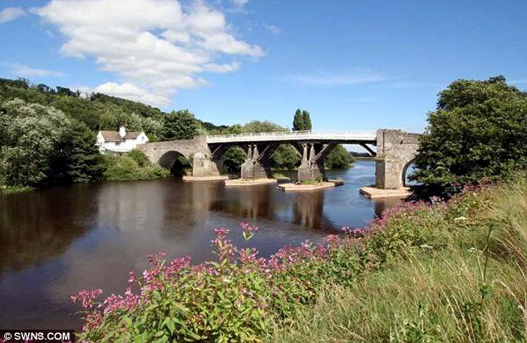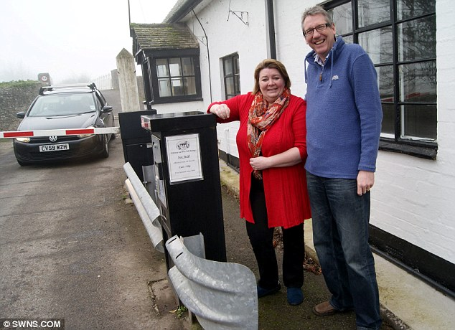
Sources: “For sale, the tax haven bridge where owner can earn £2,000 a week in tolls” http://www.dailymail.co.uk/news/article-1389670/Tax-haven-bridge-Whitney-Wye-Herefordshire-sale.html;and
“The £400,000 toll bridge and cottage that will earn new owners tax-free £100,000 a year - thanks to law from 1779” : http://www.thisismoney.co.uk/money/mortgageshome/article-2088792/400-000-Whitney-Wye-toll-bridge-cottage-earns-owners-100-000-year--1779-law.html#ixzz23lfpBi5q, accessed August 15, 2012
Soon thereafter we entered Wales at Y Gelli Gandryll aka Hay-on-Wye, a town once famous for its flannel production in the 1900’s, not surprising considering the large number of sheep in the area. Now its claim to fame is ‘world renowned for books and bookshops’. We did not stop to check this, but continued along narrow country lanes, hedges on both sides. From time to time they ceded, providing us with more than a few glimpses of a very attractive landscape. To the east the forested Black Mountains, a somewhat subdued ridge, the Wye valley to the west and to the south across the Usk River, a more pronounced ridge of the same Black Mountains. Just before the village with the almost unpronounceable name of Blwch, there was Llangorse Lake adding its serenity to the landscape. From Blwch it was a long and fast descent to the Usk (Wysg) River valley. Hee-haw! Then across the bridge and there it was, tucked again the ridge, Tallybont-on-Usk with our second control: the White Hart Public House (Km 160 @ 14:30). We stopped for an extended lunch. The menu offered some special dishes: camel burger, which I unfortunately noted too late. I would have like to try that.

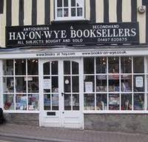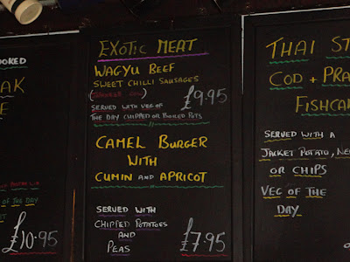
Bookstore in Hay on Wye Menu at the White Hart Public House
Source: http://challengemenace.blogspot.ca/2012_08_01_archive.html, accessed Aug 15, 20102
Well rested, fed and rehydrated we commenced our next leg: 100 km to the third control. The route followed the picturesque Usk River downstream to Abergavenny, which by the way is the hometown of 2013 Summer Games Team BC cycling coach Richard Wooles. Abergavenny also brought back musical memories through an association with the 1968 song by the same name, sung by Marty Wilde. I digress, so back to the brevet. In Abergavenny Roy skillfully manoeuvred us through the present and out of town on our way to Usk. To reach Chepstow we had to scale one more incline, a steady 6% climb to the top. Described as ‘long, steep but not quite a killer’ this one was very pretty and reminded me a lot of the Chuckanut Drive near Bellingham (WA) with its great climbing and beautiful views. Both ascent and descent were inspiring. We stopped in Chepstow (Km 220 @ 17:45) at Coffee # 1 for a quick recovery break and then back into traffic to cross the 3km long bridge across the Wye and Severn. This impressive bit of engineering -- opened in 1966 -- serves as an important transportation link between England and Wales. There was a toll booth on the East side (bicycles exempt), which made us wonder where the toll fees would end up: England or Wales. While Roy indicated that there were some concerns about cable corrosion, this did not to take away from the awe of the crossing the bridge.
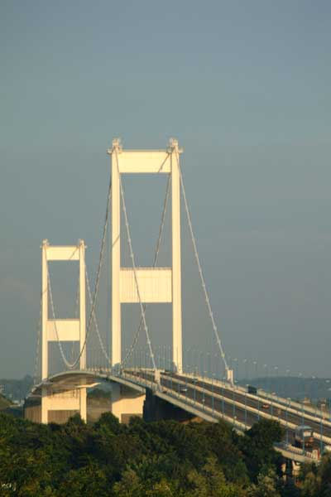
Source: http://www.freefoto.com/preview/42-12-52/The-Old-Severn-Bridge Accessed August 15, 2012
We had been bucking a bit of a headwind for most of the afternoon, but as soon as we crossed the Severn estuary and turned north, that problem solved itself. The terrain was mainly flat as we moved along the river`s floodplain. Some of the lanes were very narrow and looked almost abandoned (Slimbridge lane). Luckily Roy and Mark, whom we had picked up along the way, knew their way around and got us to the Slimbridge control, another public house (Km 260 @ 20:00). Then only 40 km to go! We cycled on gravel towpaths along the Gloucester and Sharpness Canal into Gloucester, one of Britain`s largest inland port cities. The dock lands had suffered serious economic decline in the early 1980`s.

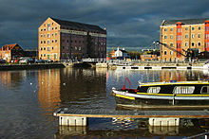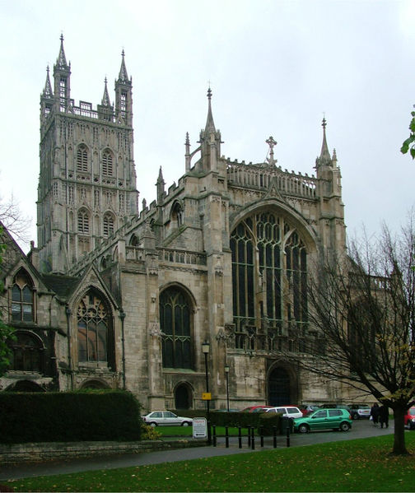

Gloucester Docklands Gloucester Cathedral
Source: http://en.wikipedia.org/wiki/Gloucester. Accessed August 15, 2012
Since that time it area has reinvented itself as a shopping and leisure destination, which includes a waterways museum, movie theatres, antique centres, and bars and restaurants. The brevet route – while a bit of a labyrinth at dusk - gave us an excellent impression of these changes as well as some of the magnificent historic buildings, specifically the large Gloucester Cathedral. By the time were in the down town area, it was dark. We made into Tewkesbury (Km 301 @ 22:20), where Mark and his wife Lou treated us to good food and great hospitality. Much appreciated.

In some retrospect this brevet was over too soon. I particularly enjoyed exploring a new part of the world- albeit in a cursory way. Any region has its own peculiar characteristics consisting of its physical geography modified by several layers of human activity, superimposed and imprinted over long periods of time on the previous. Each layer is modified by the next one, sometimes erased all together, yet at other times a hybrid landscape results. It is fascinating to try and make some sense of this palimpsest. Cycling provides an excellent opportunity to do this. Not only absorbing the physical elements and processes and their nuances, but also the artifacts left behind by humans in the form of settlement, architecture, industries and land uses. Several clues can be obtained from place names in the field and on maps, which of course in case of the Welsh landscapes requires some translation. Useful in this case was the UK ordinance survey:
(http://www.ordnancesurvey.co.uk/oswebsite/freefun/didyouknow/placenames/welshglossary-a-b.html) Riding a brevet in this new environment was certainly an invigorating and memorable experience, thanks to everyone who contributed. Highly recommended!
For results: http://www.aukweb.net/results/detail/this/listevent/?Ride=12-6

* * * * *

