John Richard Bates

October 28th, 2023
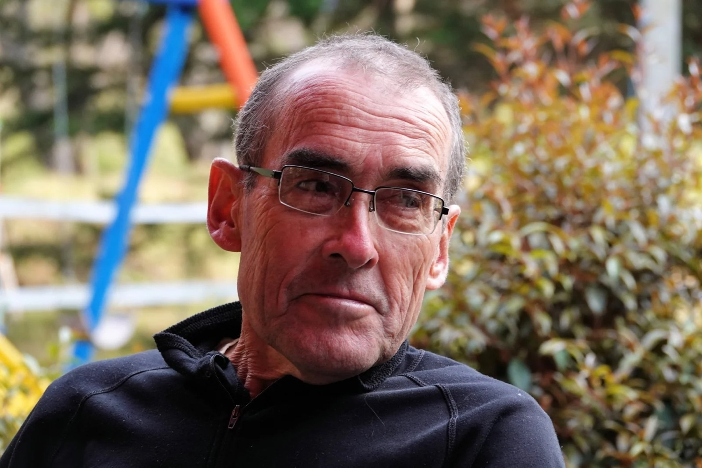
John Richard Bates was born in Epsom, England, the third of four children - his brother Chris 7 years older, his sister Gillian 4 years older, and then a gap of 8 years to his brother Phil. John’s father was a high school math teacher and later on, a professor in the Department of Education at UBC while his Mum was a homemaker. His parents died in the mid-2000s, both in their eighties.
When John was almost two, his parents emigrated to Canada and the family ended up in Trail, BC and spent the next five years there. At least once during the summer months, the whole family packed up and went on a camping trip to various parts of BC. John’s love of the outdoors, wilderness, and adventures began at a very early age!
In 1960, when John was 7, the family moved back to England where his dad had got a teaching job in Kirby Lonsdale, just south of the Lakes District. According to family lore, his parents then spent the next two years earning enough money to hightail it back to BC! They lived in Kamloops for a year before finally settling in White Rock in 1963.
John was always a good athlete. He excelled at ice hockey and might have pursued a career in it, but the fighting wasn’t to his liking. Calling himself a “rink rat”, he hung out at the ice arena a lot and managed the music for public skating. Later on in his teens, he joined a lacrosse team and played that sport for a few years. His love of cycling also began at an early age with his first job - a paper route. He’d head out before breakfast on his bike to fling papers at porches and front doors, and knowing John’s tendency for precision, the newspapers would always land in the right spot!
John trained to be a land surveyor at BCIT. Upon graduation, he was offered a job at BC Hydro and was there for his whole working career of 36 years. He thoroughly enjoyed his job. It offered precision which satisfied his mathematical and analytical skills, and it offered field work which satisfied his love of the great outdoors. The summer overtime gave him time off during the winter months so he could pursue other adventures and spend time with his growing family. His son Jack was born in 1983 and daughter Robyn in 1984. Eventually the job turned into more of an office desk job as things became computerized, but John adjusted and excelled at this too.
If you were to ask John what his most memorable adventure was, he would undoubtedly say it was the two trips to Nepal in 1975 and 1980. Mountains always beckoned him for hiking, backcountry skiing, mountaineering, orienteering, and eventually cycling, which was to become a huge part of his life. John preferred the longer bike rides of 1000 kilometers and over. On these ones he felt you really “went somewhere and saw something”. In 2000, John started working with Danelle to organize bike tours of BC. Following his retirement from BC Hydro in 2010, John continued to work with Danelle on TourBC and eventually tours in Turkey (TourTK), Colombia (TourCO), and Albania (TourAL). They also did cyclotouring in other parts of Canada, US, Europe, Africa, and South America.
In 2015, after cycling in Colombia and experiencing ongoing neck pain, John was diagnosed with Multiple Myeloma. With treatment he was eventually able to resume a normal life. Then in 2019, after completing several 200-kilometre rides and a 23-day tour of the Baltics, old injuries started to affect his knees and hips. The pandemic touched everyone and the limitations on normal interactions, social engagements, and medical procedures made life difficult, but John finally got a hip replacement in June of 2022.
Over the years, chemotherapy had taken a toll on John’s immune system, and he found his energy diminishing. When he could no longer cycle as fast or as long as he would like, John put his energy into learning how to cook. Being a lover of curries, he became especially adept at creating Indian, Thai, and Persian dishes.
2023 was a tough year with a bout of sepsis during which John developed A-Fib, followed by a bike crash, then a stroke during an appendectomy, plus coping with a chronic bladder infection. However, John still managed to get out on his bike regularly right up until he contracted Covid in August. Shortly afterwards he developed respiratory problems and was in and out of hospital for the month of September, and subsequently required Home Care three times a week in October until his last hospital visit at the end of the month.
But ever the optimist, John started a home renovation project the last week of September. In between nurse visits and naps, he still found the energy to oversee putting down cork flooring with his labourer Danelle. He knew time was short but was resolved to knock off a few items on his To Do list.
John bore his lengthy illness with dignity and humour, once saying that “the Myeloma treatments were so successful, I’ve lived long enough to develop other cancers.” John loved life. He was determined to get things done, do them right, and then move on. He was true to himself up to the very end. Carpe Diem and Rest in Peace.
Donations in John’s name can be made to:
VGH Foundation - vghfoundation.ca or
Myeloma Canada - myelomacanada.ca

Messages:
I send my sincere condolences during this time of sorrow. The Bible promises that your loved one will live again on a beautiful paradise earth when death will be no more. (John 5:28, 29; Revelation 21:4)
Lin Ellis , Montreal , Montreal , Canada
I miss you and your calm and thorough approach to tasks. And remember, I will always be your BB.
Danelle Laidlaw, Burnaby, BC, Canada

