JuMMp: Another 200 km Alberta Brevet 2017
By E.W. (Wim) Kok
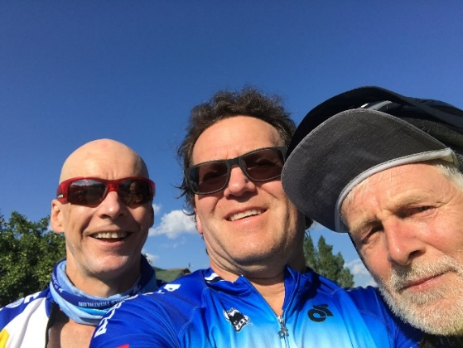 Allan, Jeff and Wim at the finish in Jasper, AB.
After a lay off about three weeks in July due to an ugly fall on the early summer Peace 200, yet fortunate enough not to have suffered any ill effects, I was ready to get back on the road. After carefully testing bike and body on the rollers and a long training ride all was well. JuMMp, a bastardized acronym for Jasper – Malign Lake – Pocahontas - Miette Hotsprings and back to Jasper back is a beautiful ride in the Rocky Mountains. The setting speaks for itself. The ride has its challenges and rewards. It starts with a 48km sustained climb from Jasper to Maligne Lake gaining more than 600 m in elevation with a few 12% inclines. The return is the reward, which is covered in almost no time flat. What follows is a 45 km almost dead flat section to Pocahontas, where a headwind may be the only fly in the ointment. What’s left at Pocahontas is 17.5 km to Miette, mostly uphill with ~ 330 m elevation gain and grades up to 10%. Again, the reward comes on the return, flying down hill to Pocahontas. Then back to Jasper, with the hope that in terms of wind the fly stays out of the ointment.
Allan McAllister, Jeff Shmoorkoff and I left Jasper at 7:10am -- rather chilly I might add. Jeff is of course a very long time randonneur with deep roots in both BC and Alberta. He is a tireless promoter of the sport. He not only established the AB (Rocky Mountain) Randonneurs, but also got Nick Lees of the Edmonton Journal to write some great articles about PBP back in 1991. Allan is another sport leader, who had a deep and long involvement in chairing and organizing the famous 24 hour Jasper-Banff Relay a few decades ago. An incredible event in which I participated twice. We did reminisce about that event. I was in good company.
Steady climbing out of Jasper got us to Medicine Lake, the one that just about disappears every fall as the flows go underground. After a few moments admiring the lake, we continued. As I focused on the next climb, Allan and Jeff hooked off – for reasons explained a bit later. I cycled passed a row of parked cars. The tourists had exited their vehicles and lined up as bear-bait to take pictures of a huge black bear, less than 15 meters away. Cycled past the action and then slowed down to let Allan and Jeff catch up.

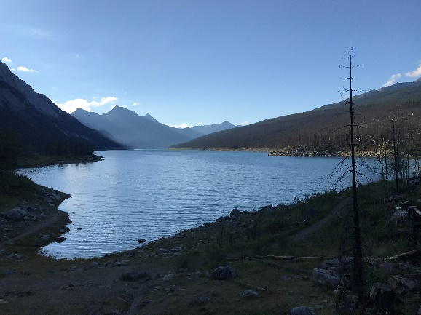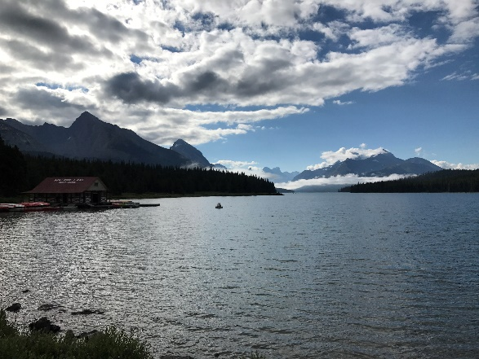
Medicine Lake Maligne Lake
They explained that, as we started the ascent, an earlier black bear had scooted out the bushes and almost collided with Allan. Some excitement there. The rest to Maligne Lake (Km 48 @ 09:40am) was uneventful as far as wildlife is concerned. The return from Malign Lake to Maligne Canyon (Km 86@11:10) was very fast. A quick food stop and then east to Pocahontas, with a headwind that was stronger that predicted. Yet, we averaged about 24 kph. Cycled by four mountain sheep; they were so close I swear I could have touched them; they did not blink one eye. I let them be. After a stop at Pocahontas (Km133@13:20), the road to the Miette Hotsprings was the real challenge -- uphill for most of it Near the end I had to stop and address a potential bonk. Instead of dipping in the hotsprings (Km148@15:10), we settled for a meal and then turned around. With less than 2km of climbing and flat section, the rest was real flyer – very nice, until - with 4 km to go to Pocahontas -- I hit an unexpected pothole - partly avoided it, but did get a slow pinch flat in the rear tire. Made it to Pocahontas, then fixed the problem. With some 48km to go and a tailwind, we cruised at 32-35kph to Jasper (Km208@18:10). Finished in 11 hrs flat, not fast. Considering the heat, the climbs and the breaks a respectable time in good company. Thanks gentlemen. It was more than memorable. That is what counts most.
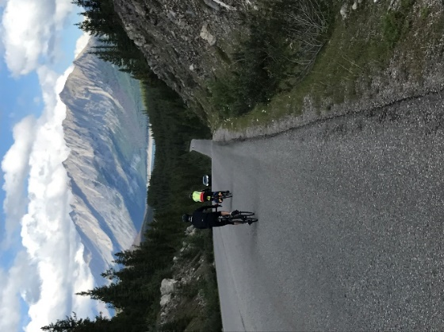 Descent to Maligne Canyon. (Credit for all photos: Jeff S.)

