SHAKE DOWN RIDE OF PERMANENT #98 – PARKS GALORE 200

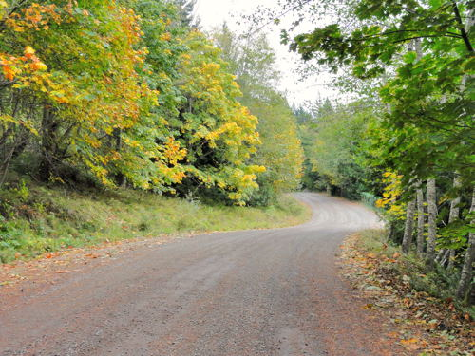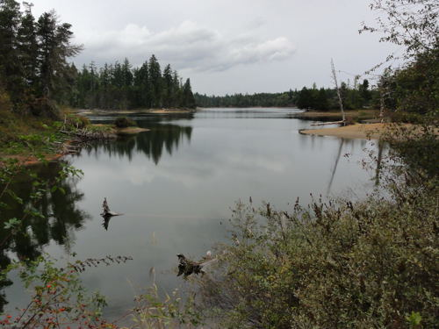
Photos: Horne Lake Caves Road (left) and Spider Lake (right)
This new permanent brevet makes its way through some scenic Vancouver Island parks and has a rather unusual structure. With several out-and-back spurs to points of interest, the route map resembles a spider after Garfield has whacked it with a newspaper.
I set out dark and early on October 17 to check the route sheet I’d prepared and to finalize some of the information controls. The forecast was for cloud and showers and the temperature was only 3 degrees.
The first leg, to Englishman River Falls, was only 37 km from the start in north Nanaimo. Just after I got out of town I had to stop to change my bike computer battery and later to switch to warm lobster claw cycling mitts. Not a good start. I had to rush to reach the first control before closing time. Even so, the ride became enjoyable once I reached the back roads of Errington. Riding past the Unicorn Farm I looked for “unique livestock”, but didn’t see any. Later the view opened to a pastoral vista with an aging barn, expansive fields and a mountain backdrop. Much better. I made it to the control with 24 minutes to spare.
The next 31 km took me through Coombs and out to Cathedral Grove. Riding past Cameron Lake on a bike has its good and bad points. On a bike you have more time to take in the scenery – the lake is so close! – and there is no car between you and the view. On the other hand, at about 64 km there is a blind curve with no shoulder and no room to get off the road. There it would have been reassuring to have a car frame and crumple zone between me and any inattentive, on-coming driver. There wasn’t much traffic on the 17th, so I was able to relax and enjoy.
Next stop was Horne Lake Caves Provincial Park less than 50 km away. I stopped at a convenience store in Whiskey Creek because I wasn’t sure what would be available in Horne Lakes Provincial Park. That turned out to be a good move because the visitor centre was closed and I didn’t see another convenience store for about another 65 km.
Riding the back roads around Horne and Spider Lakes – the quiet winding country road with rolling hills and the trees in their fall colours – was memorable. No doubt my tinted cycling glasses contributed to the effect, but this section of the route was the highlight for me.
Back on the pavement I still had about 80 km and three controls before the finish. I reached the next control with an hour to spare, but the fact that I hadn’t ridden much since the Aug 11th 300 km brevet was starting to show. I was getting tired. I ground out the remaining distance and finished in 13h 4min, good enough to get my October ride for the BC-12. Five down, seven to go. On top of that, this is a ride I’d like to do again.

